Frequencies, Counts, & Distributions

Overview
- Frequencies & relative frequencies
- Probabilities
  - Risks & risk ratios
  - Hazards & hazard ratios
- Odds & odds ratios
- Contingency / cross tables
  - Fisher’s exact test
- Important distributions
  - Normal distribution
  - χ² distribution

Frequencies &Relative Frequencies

Frequencies
- Simply how often something occurs
- But can be expressed differently:
- Relative to the entire sample
  - “Of all 100 patients, 80 had pain disorders”
  - Presented as percents, probabilities, or risks
- Relative to other subgroups
  - “80 of these patients developed pain disorders, and 20 did not”
  - Presented as odds
    - “The odds of these patients developing a pain disorder were 4:1”

Relative Frequencies
- We’re often interested not only in how something happens
  - But if it’s more/less common in one group/situation than in others
- This is the relative frequency
  - Can be expressed as:
    - Relative risk (relative probability)
    - Relative odds
  - These are usually instead written as:
    - Risk ratio
    - Odds ratio

Risks (Probabilities)& Risk Ratios

Risks/Probabilities
- Again, risk & probability are the same thing
- Expressed as the chance of something happening standardized to a scale of 0 to 1
  - Often computed as the chance—or number of times—something happens out of all possible times
$$P(Targetoutcome)=\frac{Numberoftargetoutcomes}{Numberofalloutcomes}$$
$$P=\frac{72}{200}=.36$$

Risks/Probabilities (cont.)
- Creating an example in R using RStudio
pain.df <- data.frame(Ethnicity = c("Latin", "Non-Latin"),
Diagnosed = c(72, 223),
Not_Diagnosed = c(128, 241)
)
- <- assigns a value, function, etc. to an “object”
  - Here I’m creating a data.frame
  - And assigning it to / saving it as pain.df
- c “concatenates” (combines) a series of values, etc. into a single list (“array” or “vector”)

Risks/Probabilities (cont.)
library(knitr)
library(kableExtra)
table.of.pain <- pain.df %>%
kable(col.names = c("Ethnicity", "Diagnosed", "Not Diagnosed"),
align = c("l", "c", "c")) %>%
kable_styling(font_size = 42) %>% kable_material("hover") %>%
add_header_above(c(" " = 1, "Pain Disorder Diagnosis" = 2))
- Most functions in R are available in add-on packages; library invokes a given package
  - knitr prepares output for reports
  - kableExtras pimps out tables (kables) made by knitr
- %>% is a “pipe” command, which essentially nests commands inside other commands
  - I’m piping commands to tweak the table into the pain.df data frame
  - And having all of that assigned to the table.of.pain object

Risks/Probabilities (cont.)
- Simply giving the name of an object invokes it
  - (Kinda like Satan)
table.of.pain
 | Pain Disorder Diagnosis
Ethnicity | Diagnosed | Not Diagnosed
Latin | 72 | 128
Non-Latin | 223 | 241

Risks/Probabilities (end)
$$P(LatinoPatientHasaPainDisorder)=\frac{TargetEvent}{AllEvents}$$
$$\frac{Latinos\overline{c}PainDisorders}{(Latinos\overline{c}PainDisorders)+(Latinos\overline{s}PainDisorders)}$$
$$\frac{72}{72+128}=\frac{72}{200}=.36$$

More Computations with R
- Brackets ([]) index parts (“elements”) of an object
pain.df[1, 1] # First row, first column
## [1] "Latin"
pain.df[1, 2] # First row, second column
## [1] 72
pain.df[1, ] # The whole first row
## Ethnicity Diagnosed Not_Diagnosed
## 1 Latin 72 128

More Computations with R (cont.)
pain.df
## Ethnicity Diagnosed Not_Diagnosed
## 1 Latin 72 128
## 2 Non-Latin 223 241
pain.df[1, 2] + pain.df[1, 3]
## [1] 200
p.latin.patient.diagnosed.with.pain.disorder <- pain.df[1, 2] / (pain.df[1, 2] + pain.df[1, 3])
p.latin.patient.diagnosed.with.pain.disorder
## [1] 0.36

More Computations with R (cont.)
- $ accesses a column (or other variable-like element) of an object…
pain.df$Ethnicity
## [1] "Latin" "Non-Latin"
pain.df$Diagnosed
## [1] 72 223

More Computations with R (cont.)
- We can do computations etc. on these columns
pain.df$Diagnosed / (pain.df$Diagnosed + pain.df$Not_Diagnosed)
## [1] 0.3600000 0.4806034

More Computations with R (cont.)
- And assign those computations to an element
  - That’s also part of that data frame
pain.df$Risk_of_Pain_Diagnosis <- pain.df$Diagnosed /
(pain.df$Diagnosed + pain.df$Not_Diagnosed)
pain.df$Risk_of_Pain_Diagnosis
## [1] 0.3600000 0.4806034
pain.df
## Ethnicity Diagnosed Not_Diagnosed Risk_of_Pain_Diagnosis
## 1 Latin 72 128 0.3600000
## 2 Non-Latin 223 241 0.4806034

More Computations with R (end)
- The risk ratio is simply the ratio of these risks:
$$RiskRatio=\frac{RiskAmongLatinoPatients}{RiskAmongNon\text{-}LatinoPatients}$$
$$\frac{.36}{∼.48}≈.75$$
risk_ratio <- pain.df$Risk_of_Pain_Diagnosis[1] /
pain.df$Risk_of_Pain_Diagnosis[2]
risk_ratio
## [1] 0.7490583

Hazards &Hazard Ratios

Hazards & Hazard Ratios
- Hazard is simply risk within some time frame
  - “What are the risks of relapse within one year?”
- Hazard ratio is the hazard in one group relative to an other
  - “What are the risks of Latino patients relapsing within one year compared to non-Latino patients?”

Presentation of Hazards
- Since events in a time frame may not be uniform,
  - Hazards / hazard ratios are often accompanied by “Kaplan-Meier curves” depicting events over time
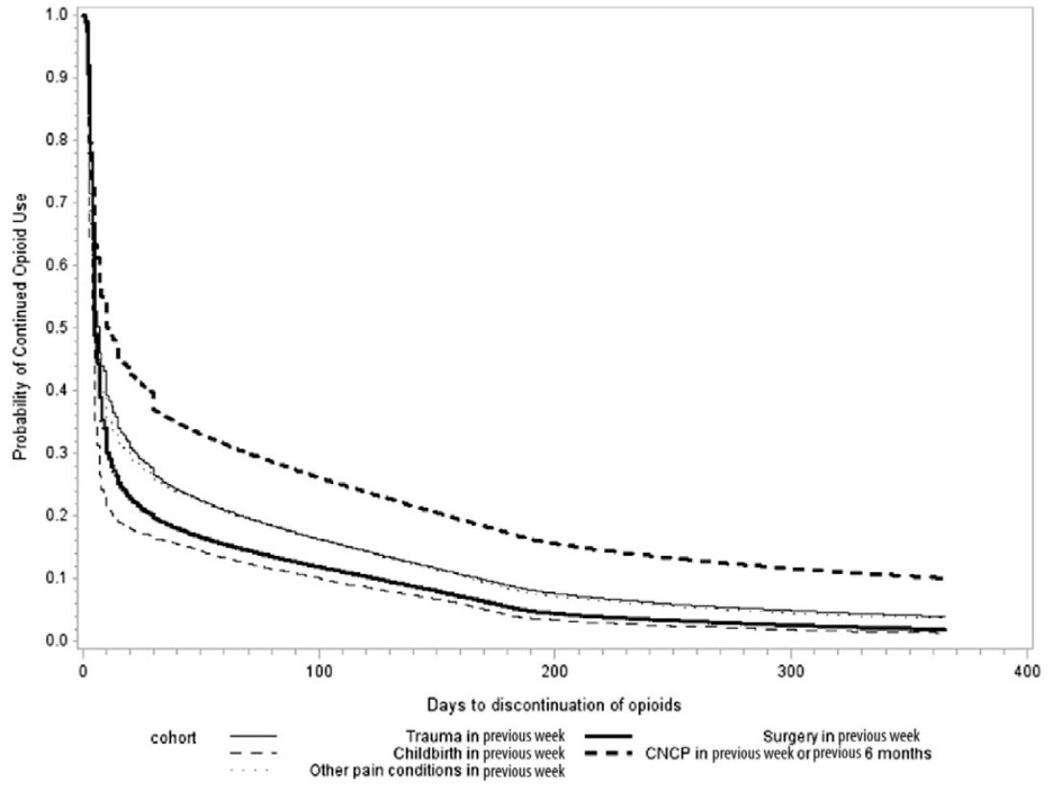
Probability of continued opioid use for ≤ 365 days for patients with childbirth, surgery, trauma, or other pain diagnosis in the week before their first opioid prescription or chronic pain diagnosis in the 6 months before their first opioid prescription.Abbreviation: CNCP, chronic non-cancer pain Shah, Hayes, & Martin (2017)

Analyzing Hazards
- Cox proportional hazards regression
  - Tests if variables can significantly predict hazard (time-to-event)
  - Handles “censoring” well
    - When we don’t know how long it was to an event because, e.g., the event didn’t happen during the study
      - (E.g., the patient survived until at least the end of the study window)
  - Assumes that the effect of each predictor on the outcome is consistent throughout the study
    - E.g., there is no seasonal effect

Example of Cox Regression
- Brahmania et al. (2025)
  - Investigated the effects of a dedicated, automated recall hepatocellular carcinoma (HCC) surveillance program on retention
    - Among 7,269 Canadian patients with a confirmed diagnosis of cirrhosis of any aetiology
    - Who were automatically enrolled in a surveillance program
  - Predictors of retention (returning for screenings):
    - Patients who identified as Asian were most likely to return for semi-annual screenings (of races)
    - Patients diagnosed with Hepatitis B, autoimmune, or alcohol-induced cirrhosis least likely (of aetiologies)

Example of Cox Regression (cont.)
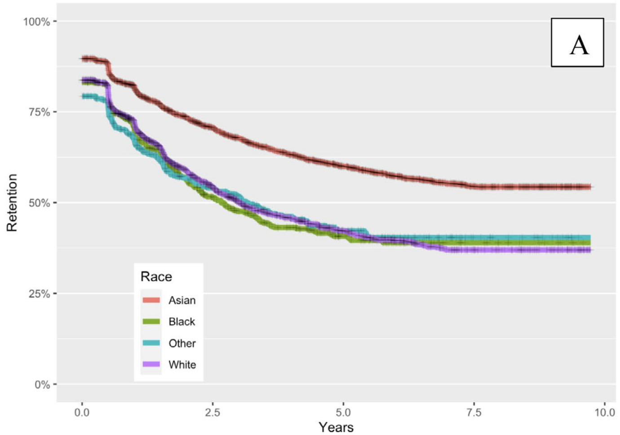

Example of Cox Regression (cont.)
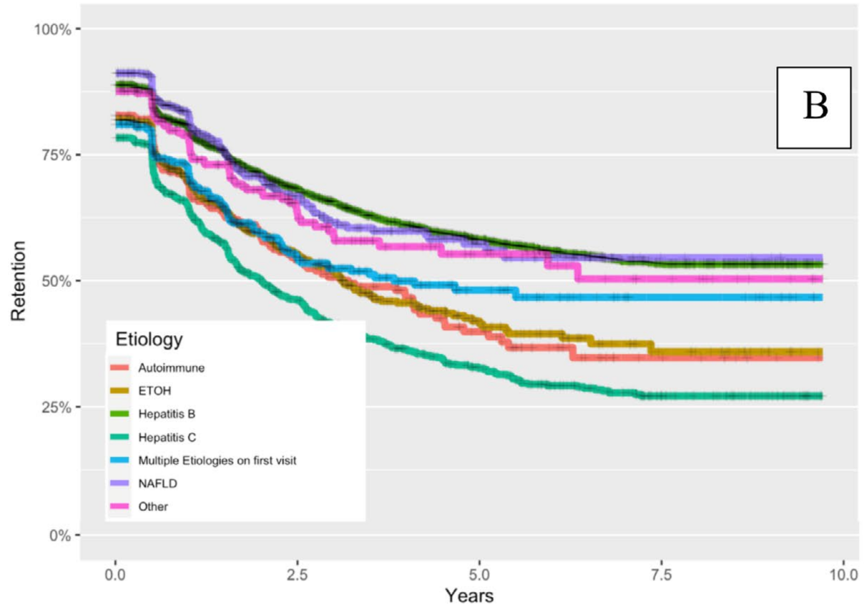

Example of Cox Regression (end)
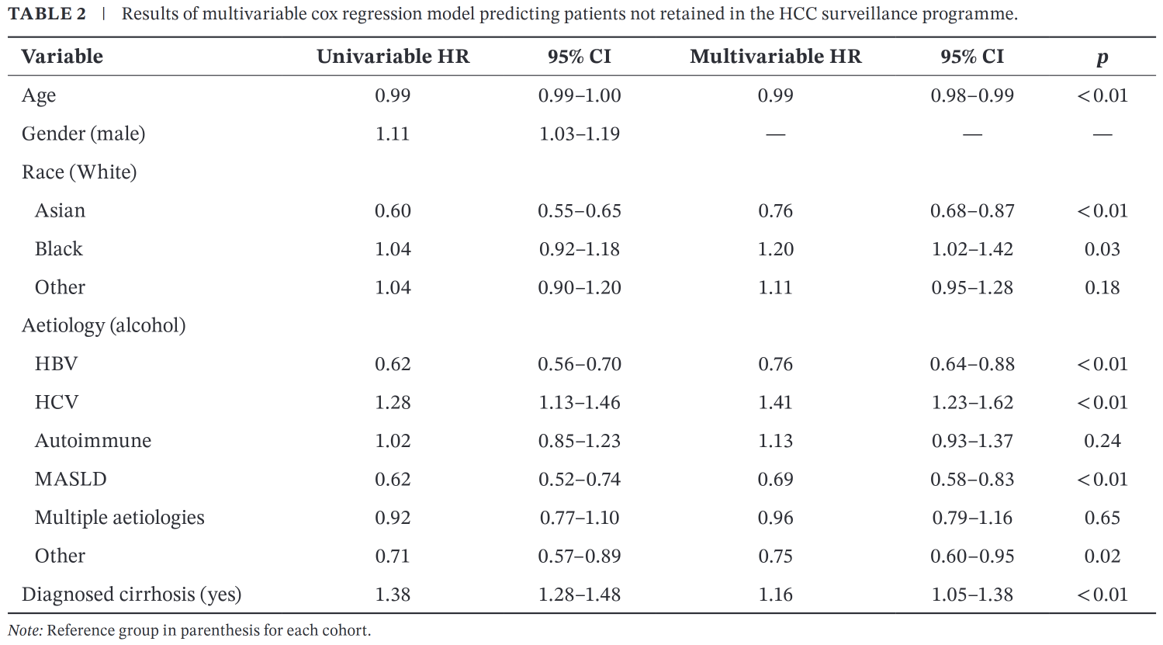

Odds &Odds Ratios

Risks vs. Odds
- Probability is the chance of something happening out of all possible occasions
  - E.g., of the 200 Latino patients with OUDs, 72 were diagnosed with pain disorders
$$P(BeingDiagnosed\overline{c}PainDisorder)=\frac{72}{72+128}=\frac{72}{200}$$
- I.e., $\frac{72}{200}=.36≈\frac{1}{3}$ of all Latino patients with OUDs were diagnosed with a pain disorder
“36% of these Latino patients with OUDs were diagnosed with a pain disorder.”

Risks vs. Odds (cont.)
- Odds are the chance of something happening relative to them not happening
  - E.g., 72 Latino patients were diagnosed with pain disorders
  - 128 Latino patients were not so diagnosed
$$OddsofBeingDiagnosed\overline{c}PainDisorder=\frac{72}{128}≈.56$$
“Among these Latino patients with OUDs,
For every 1 diagnosed with a pain disorder,
There were about 2 who were not (odds = 0.56).”

Examples of Odds
Event Happening | Odds Versus the Event Not Happening
Dying in a plane crash | 1 : 11,000,000
Dying in a shark attack | 1 : 7,000,000
Being killed by a meteorite | 1 : 250,000
Dying in a hurricane | 1 : 62,288
Dying in a motorcycle accident | 1 : 722
Dying by heart disease | 1 : 6
Being saved by CPR | 1 : 1.44
Being an adult with hearing issues | 1 : 6.14
Being an elderly adult with hearing issues | 1 : 1
Earn any degree within 6 years of enrolling in a 4-year for-profit college | 1 : 1.68
Earn any degree within 6 years of enrolling in a 4-year public college | 1 : 0.52
Having an application accepted by Harvard | 1 : 30.25
Identifying as LGBTQ+ | 1 : 16.86
Being audited by the IRS | 1 : 220
Giving birth on the actual due date | 1 : 249
Getting your car stolen | 1 : 332
Being matched as a bone marrow donor | 1 : 430
Loosing your home to fire | 1 : 3,000
Finding a four-leaf clover | 1 : 10,000
Being involved in a mass shooting | 1 : 11,125
Getting struck by lightning within an 80-year life | 1 : 15,300
Winning an Olympic medal | 1 : 622,999
From Stacker

Odds Ratios
- Odds ratios (OR) represent the odds of an event in one group proportional to the odds in an other
  - E.g., OR = .5 means the odds in the target group are half the odds in the reference group
    - E.g., the odds in the target group are 2:1
      - While the odds in the reference group are 4:1
- Turning back to the OUD study may help…

Odds Ratios: Example
Ethnicity | Diagnosed | Not Diagnosed
Latin | 72 | 128
Non-Latin | 223 | 241
Odds—not odds ratios—for each group:
- Odds of pain diagnosis among Latino patients with OUDs: $\frac{N_{Latinos\overline{c}PainDisorders}}{N_{Latinos\overline{s}PainDisorders}}=\frac{72}{128}≈.56$
- Odds of pain diagnosis among non-Latino patients with OUDs: $\frac{N_{non−Latinos\overline{c}PainDisorders}}{N_{non−Latinos\overline{s}PainDisorders}}=\frac{223}{241}≈.92$

Odds Ratios: Equation
Group | Present | Not Present)
Target | A | B
Reference | C | D
$$OR=\frac{(\text{Target \& Present / Target \& Not Present})}{(\text{Reference \& Present / Reference \& Not Present})}$$
$$OR=\frac{(\text{A / B\backslash \backslash \backslash )}}{\text{\backslash \backslash \backslash (C / D\backslash \backslash \backslash )}}$$

Odds Ratios: Example (cont.)
Ethnicity | Diagnosed | Not Diagnosed
Latin | 72 | 128
Non-Latin | 223 | 241
$$OR=\frac{(\text{Latin \& Diagnosed / Latin \& Not Diagnosed})}{(\text{Non-Latin \& Diagnosed / Non-Latin \& Not Diagnosed})}$$
$$OR=\frac{({72}/{128})}{({223}/{241})}≈\frac{.56}{.92}≈.61$$
- The odds of a Latino patient being diagnosed with a pain disorder were about 61% of the odds for a non-Latino patient.

Odds Ratios: Example (cont.)
- Could also look at it from the non-Latin perspective
$$OR=\frac{({223}/{241})}{({72}/{128})}=\frac{.92}{.56}≈1.6$$
Note that $\frac{1}{.61}≈1.6$
- For every 1 Latino OUD patient diagnosed with a pain disorder, 1.6 Non-Latino OUD patients are so diagnosed

Contingency Tables &Fisher’s Exact Test

Contingency Tables
- Also called “cross tables”
- Displays the counts (frequencies) of events in different categories
  - And often used to compute probabilities
- Is usually intended to be used when outcomes are “exclusive”—that all options are presented
- IFF it is exclusive, can conduct meaningful tests on whether the frequencies differ between groups, etc.
  - Fisher’s exact test can be used to test 2 $×$ 2 tables
    - N.b., Fisher’s exact test can also be used on contingency tables larger than 2 $×$ 2
  - In fact, it’s better than χ² with small cell counts (<5)

Contingency Tables (cont.)
Yeah, like this:
Ethnicity | Diagnosed | Not Diagnosed
Latin | 72 | 128
Non-Latin | 223 | 241

- Odds among Latinos = $\frac{72}{128}≈.56$
- Odds among non-Latinos = $\frac{223}{241}≈.92$
- Odds ratio = $\frac{.56}{.92}≈.61$

Fisher’s Exact Test
- Invented to test if Fisher’s colleague, Muriel Bristol, could indeed tell if cream or tea were poured first into a cup
- Called an “exact” test because it computes the exact p-value for rejection
  - I.e., not an estimate based on inferences about the population(e.g., normality)
  - So, isn’t inferential per se

Dr. Muriel Bristol waiting for her tea

Fisher’s Exact Test Example
pain.df.counts <- subset(pain.df, select = c("Diagnosed", "Not_Diagnosed"))
fisher.test(pain.df.counts)
##
## Fisher's Exact Test for Count Data
##
## data: pain.df.counts
## p-value = 0.00491
## alternative hypothesis: true odds ratio is not equal to 1
## 95 percent confidence interval:
## 0.4250886 0.8665430
## sample estimates:
## odds ratio
## 0.6083658
- The difference in odds (0.56 vs. 0.92) is significant at α = .05
  - We see this in p-value = 0.00491
  - And that the confidence interval (0.425 – 0.866) for the odds ratio (0.608) doesn’t overlap 1

Fisher’s Exact Test Example (cont.)
- fisher.test also creates an object
- And not all elements of that object are automatically printed
- We can look to see what all is there with either the powerful & flexible summary() command:
summary(fisher.test(pain.df.counts))
## Length Class Mode
## p.value 1 -none- numeric
## conf.int 2 -none- numeric
## estimate 1 -none- numeric
## null.value 1 -none- numeric
## alternative 1 -none- character
## method 1 -none- character
## data.name 1 -none- character

Fisher’s Exact Test Example (cont.)
- Or with the more revealing str() command:
  - str() works to “look inside” most any object or function in R
str(fisher.test(pain.df.counts))
## List of 7
## $ p.value : num 0.00491
## $ conf.int : num [1:2] 0.425 0.867
## ..- attr(*, "conf.level")= num 0.95
## $ estimate : Named num 0.608
## ..- attr(*, "names")= chr "odds ratio"
## $ null.value : Named num 1
## ..- attr(*, "names")= chr "odds ratio"
## $ alternative: chr "two.sided"
## $ method : chr "Fisher's Exact Test for Count Data"
## $ data.name : chr "pain.df.counts"
## - attr(*, "class")= chr "htest"

Fisher’s Exact Test Example (cont.)
- $ can access any of those elements of the fisher.test object:
fisher.test(pain.df.counts)$p.value
## [1] 0.004910079
fisher.test(pain.df.counts)$conf.int
## [1] 0.4250886 0.8665430
## attr(,"conf.level")
## [1] 0.95

Is Fisher’s Exact Test Too Conservative?
- Fisher himself sure was
- Fisher’s exact test can mis-estimate p-values when the total N is “small” (<50; Andrés & Tejedor, 1995)
  - But this bias itself is usually small
  - And common corrections (e.g., Yate’s correction) don’t change outcomes much (Crans & Shuster, 2008)
    - While making for somewhat more complicated analyses that rely on parametric assumptions

Upton (1992)
- Upton (1992) argues that Fisher’s exact test is not too conservative
  - Trouble comes because counts are discrete
    - While p-values assume the data are continuous
- Also discusses how it can be hard to test this when something comes close to always (or never) happening
  - Essentially, cell counts that are zero (or close to it) can be problematic
- And that small cell counts can push a p-value to be larger than .05
  - See Upton’s discussion of Table 2 where the real rejection value ranged from .015 – .080

Upton (1992, cont.)
- Also notes—correctly—that significance is largely determined by sample size
  - Some argue for making α smaller as samples get larger
  - Can add confidence intervals (CIs) to the concomitant OR
    - (And perhaps p-values for the ORs at the CI limits)
  - Or even use Bayesian inferences
- Discussed “practical significance”
  - I.e., how important it is to not have false positives for a given real-world situation
  - “The experimenter must keep in mind that significance at the 5% level will only coincide with practical significance by chance!” (p. 397)

The Normal Distribution

Normal Distribution
Formula for a normal distribution:
$$f(x,μ,σ)=\frac{1}{σ\sqrt{2π}}e^{\frac{−(x−μ)^{2}}{2σ^{2}}}$$
- x is some random variable
- μ is the mean
- σ is the standard deviation
- There, now you can say you learned this

Characteristics
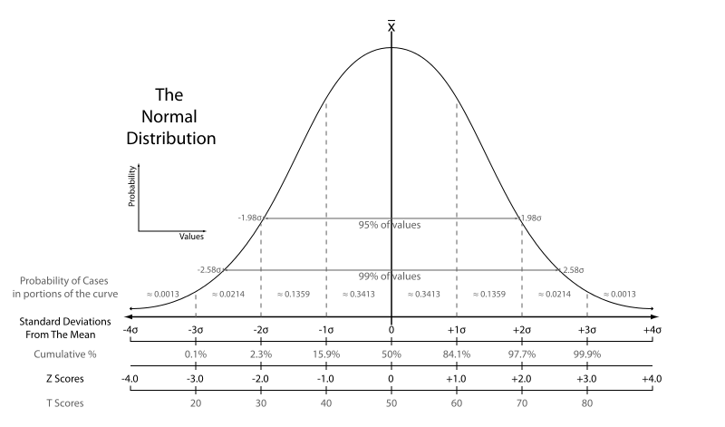

Characteristics (cont.)
- Most importantly, it is only a function of the mean & standard deviation
- The mean, median and mode are all equal
- The total area under the curve equals 1
- It’s symmetric
- The curve approaches—but never touches—the x-axis

Q-Q Plots
- “Quantile-quantile” plots
  - Compare the position in the distribution of a given quantity against the position of the same quantity in an other (e.g., normal) distribution
- More simply, how & where two distributions deviate from each other
- Frequently used to test if & how a sample deviates from normality
  - Or how residuals deviate from normality
- They’re easily created in SPSS or R
  - They can be done—less easily—in Excel, etc
- And a few examples may help understand them…

Normally-Distributed
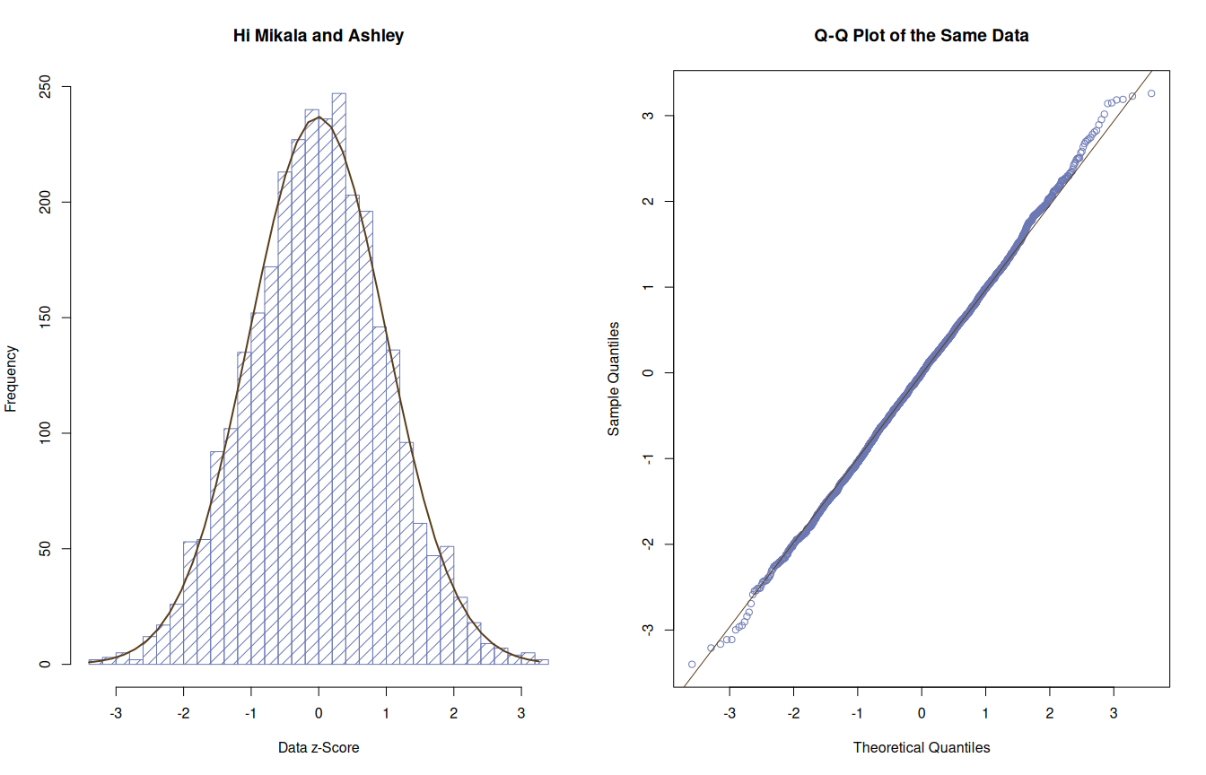

Short Tails (Looks like an S )
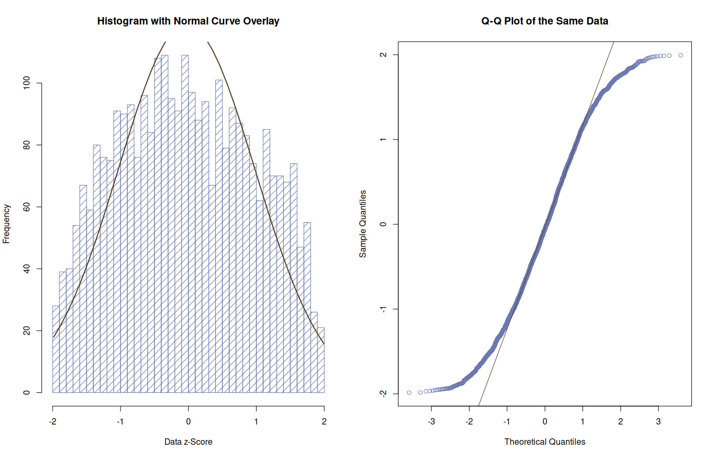

Long Tails {.flexbox .vcenter}
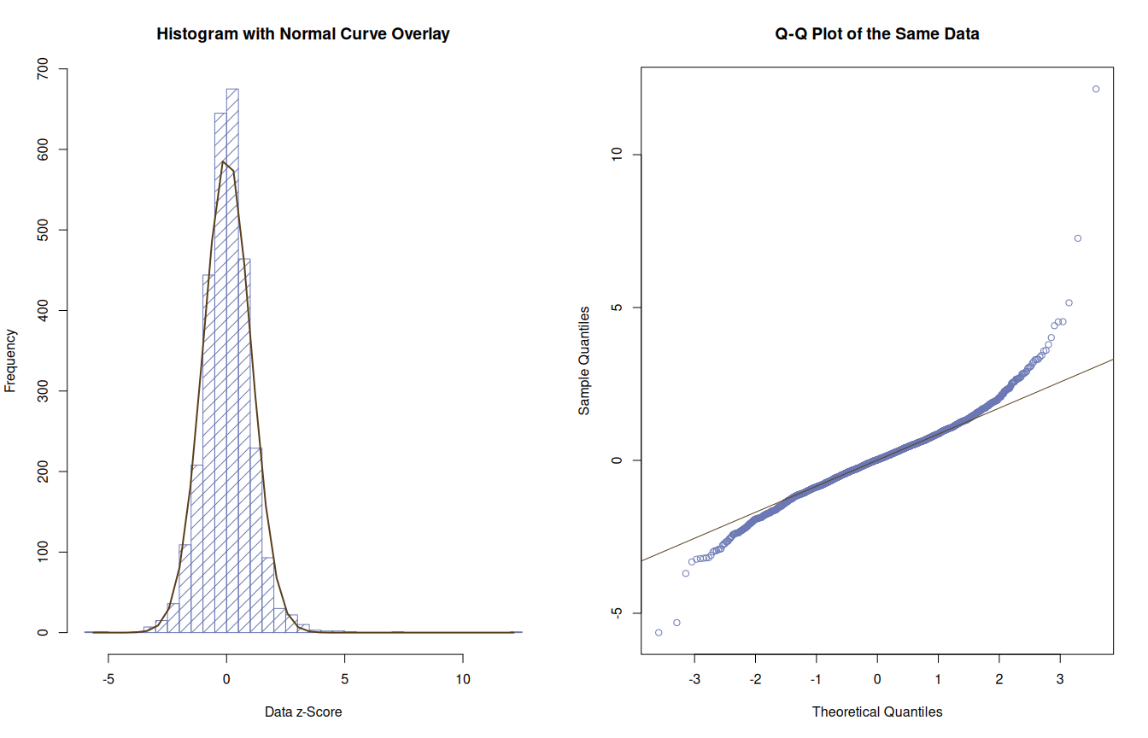

Long Right Tail (Positive Skew)
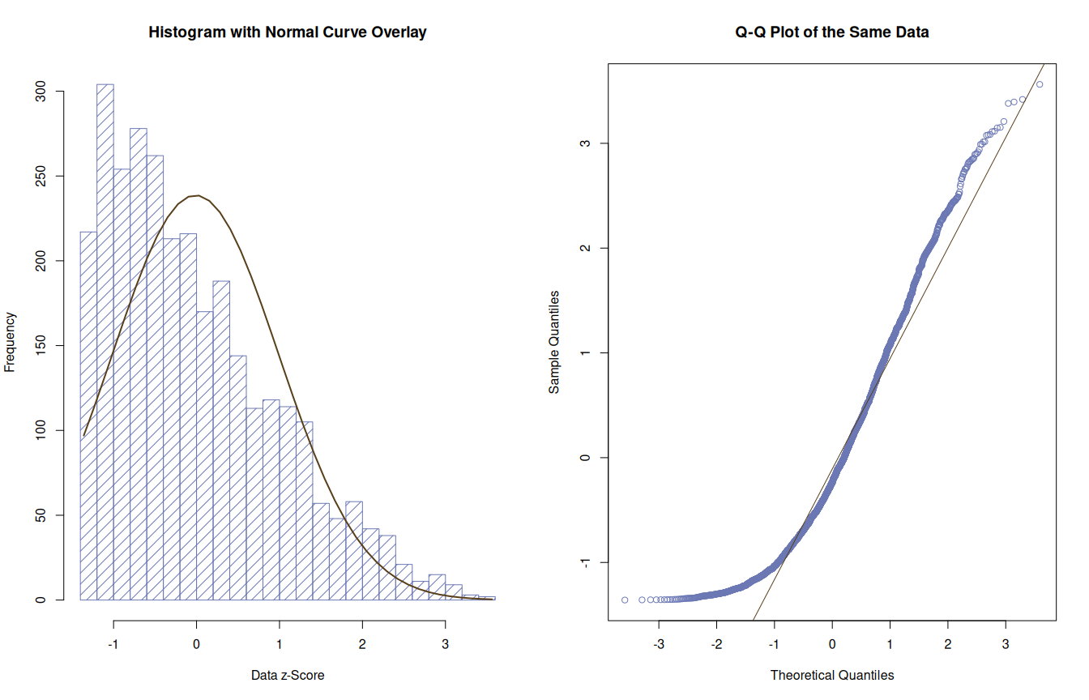

Long Left Tail (Negative Skew)
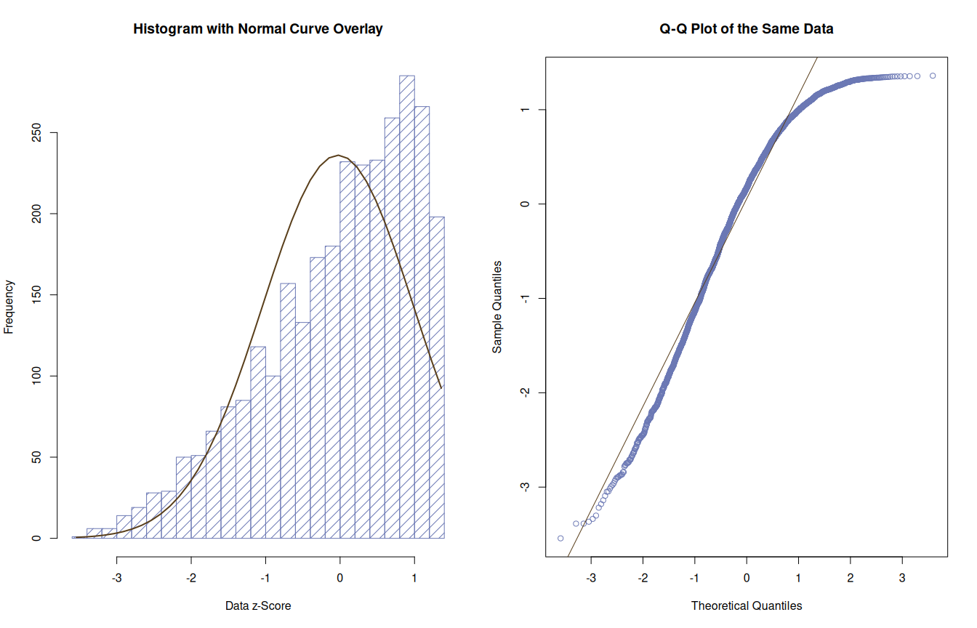

More Figures, More Views on Skew
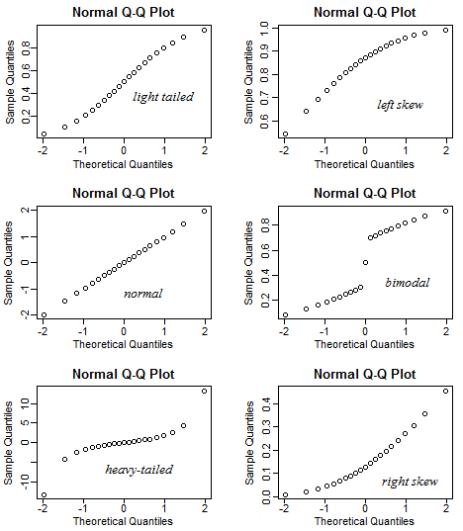
From StackExchange

Q-Q Plots (cont.)
- Can put a “confidence envelope” around data in Q-Q plots:
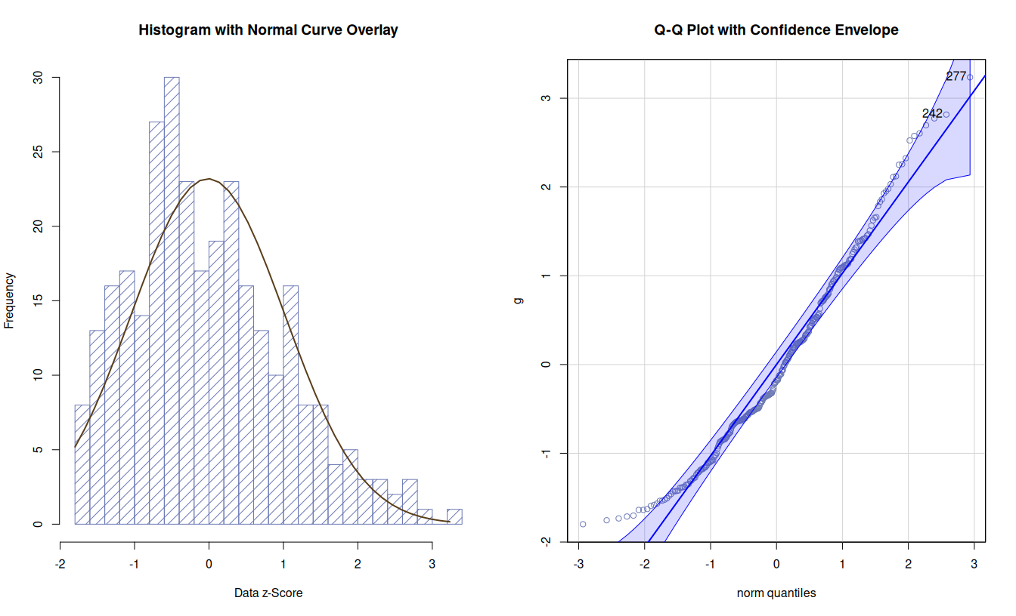

Alternatives to Q-Q Plots
- Can also/instead formally test normality of a sample with, e.g.:
  - Kolmogorov-Smirnov Test (In SPSS & R)
  - Shapiro-Wilk Test (In SPSS & R)
  - Anderson-Darling Test (In R)
- S-W and A-D are better than K-S, but all are strongly affected by sample size
  - Under-powered with small N
    - Can’t detect non-normality when we need to
  - Over-powered with large N
    - Overly sensitive to deviations when we don’t need to know
    - (I.e., have enough data to approximate population distribution without assuming normality)

The χ² Distribution

Background
- Invented by Karl Pearson (in an abstruse 1900 article)
- Originally to test “goodness of fit”
  - I.e., how well a set of data fit a theoretical distribution
  - Or if two sets of data follow the same distribution
- Technically, χ² is a type of Gamma distribution created by the distribution of sums of the squares of a set of standard normal random variables
  - A lot like we get when computing ordinary least squares for t-tests & ANOVAs
  - And is closely related to the t and F distributions

Characteristics
- The distribution’s shape, location, etc. are all determined by the degrees of freedom
  - The mean = df
  - The variance = 2df
    - SD = $\sqrt{2df}$
  - The maximum value for the y-axis = df – 2 (when dfs >1)
- As the degrees of freedom increase:
  - The χ² curve approaches a normal distribution
  - The curve becomes more symmetrical
- It has no negative values
  - Since it is based on squared values
  - Making it good to test variances

Characteristics (cont.)
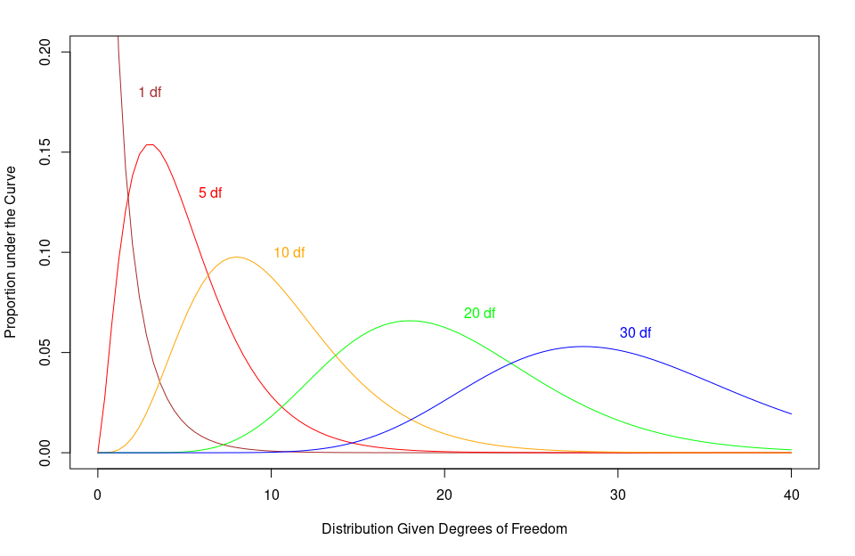

Computing χ²
Formula for χ² value:
$$χ^{2}=∑\frac{(Observed−Expected)^{2}}{Expected}$$
- Compute the differences between a data’s actual value from it’s expected value
- Square all of those differences & divide by the expected value • Kinda like computing the odds
- Sum up those square differences “odds” for each group
- Check that summed value against a χ² distribution • Where dfs = (N_{rows} – 1) $×$ (N_{columns} – 1)
- If the summed value is really far from the center of the distribution • Then those actual-expected differences are significant

Example of Using χ²
- Remember our data for Latino patients with OUDs:
Ethnicity | Diagnosed | Not Diagnosed | Total
Latin | 72 | 128 | 200
- Presenting that a little differently:
Value Type | Diagnosed | Not Diagnosed | Total
Observed | 72 | 128 | 200
Expected | 100 | 100 | 200

Example of Using χ² (cont.)
- Taking the difference between observed & expected
- Squaring those differences & dividing by expected
- Add up those values
Value Type | Diagnosed | Not Diagnosed
Observed | 72 | 128
Expected | 100 | 100
Observed - Expected | -28 | 28
- ${28}^{2}=784$ (and -${28}^{2}=784$)
- $$\frac{784}{100}=7.84$$
- $$7.84+7.84=15.68$$
- df = $(2−1)×(2−1)=1×1=1$

Example of Using χ² (end)
- The critical χ² value
  - For 1 df
  - And α = .05:
  - (lower.tail = FALSE gives the max value for a χ² from the null distribution)
qchisq(df = 1, p = .05, lower.tail = FALSE)
## [1] 3.841459
- Which is smaller than our χ² of 15.68
- So our observed values are significantly different than our expected ones

Uses of χ²
- Because it only depends on df,
  - And resembles a normal distribution.
- It is useful for testing if data follow a normal distribution
  - Or often if the total set of deviations from normality
    - (Or any set of expected values)
  - Are greater than expected
- It can do this for discrete values—like counts
  - t and F distributions technically can’t do this

Uses of χ² (cont.)
- The χ² distribution has many uses, including:
  - Estimating of parameters of a population of an unknown distribution
  - Checking the relationships between categorical variables
  - Checking independence of two criteria of classification of multiple qualitative variables
  - Testing deviations of differences between expected and observed frequencies
  - Conducting goodness of fit tests

Example of a χ² Test
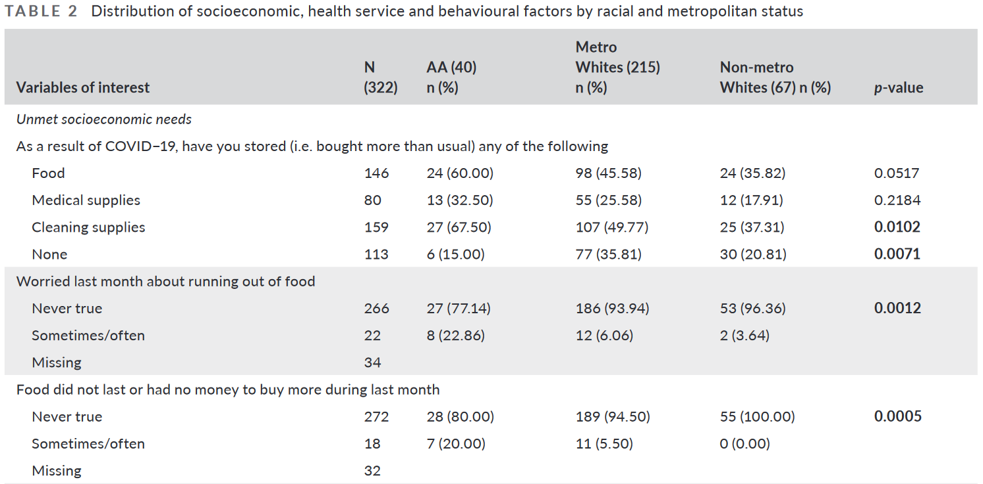
Notes: “AA” = African Americans; p-values are from tests of χ²s
Zhang, A. Y., Koroukian, S., Owusu, C., Moore, S. E., & Gairola, R. (2022). Socioeconomic correlates of health outcomes and mental health disparity in a sample of cancer patients during the COVID-19 pandemic. Journal of Clinical Nursing. https://doi.org/10.1111/jocn.16266

The End

